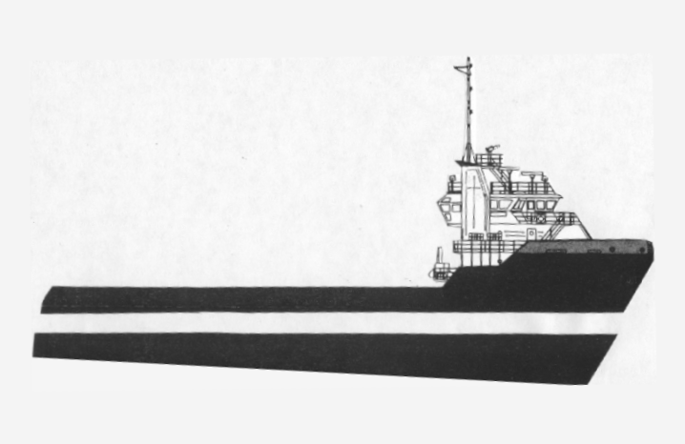
GHIRARDI 1-800-298-2419
MARINE AGENCY,Inc.

Name__________________________________ S/S#___________________________

Address____________________________City_______________ST_____Zip______

DL ID___Transportation / Own Car___Ph#_______________________________

Available for Work____________

EMPLOYMENT HISTORY

Employer_______________________________ Address______________________________________________

Phone ________________ Start Date__________ To ______________ Position___________________________

Reason for Leaving_________________________________________________________ Pay Rate___________

Employer_______________________________ Address______________________________________________

Phone ________________Start Date___________ To _____________ Position____________________________

Reason for Leaving__________________________________________________________Pay Rate___________

Employer_______________________________ Address______________________________________________

Phone _______________ Start Date____________ To ____________ Position____________________________

Reason for Leaving__________________________________________________________ Pay Rate___________

List any other qualifications & experience you may have______________________________________________

______________________________________________________________________________________________
____________________________________________________________________________________

Please Send a Copy of Drivers License or State I.D. & Social Sec. card

